**GURU NANAK DEV UNIVERSITY**

**AMRITSAR**



A PROJECT REPORT ON

**JOBIPHER**

Submitted in partial fulfillment of the requirement

For the award of the degree of

**Bachelor**

In

**Computer Science**

**By**

**Kanav Gupta**

**B-tech (CSE) 6th Sem**

**2015CSA1086**

Under the guidance of

**Mrs. Kiranbir Kaur (Guide)**

**DECLARATION**

I hereby declare that the Training Report entitled "**JOBIPHER**" is an authentic record of my own work as requirements of 6- months Training during the period for the award of degree of B-tech. **Guru Nanak Dev University** under the guidance of

**Mrs. Kiranbir Kaur.**

**Signature of student**

**Dated:**

**ABSTRACT**

Resume parsing, also known as CV parsing, resume extraction, or CV extraction, allows for the automated storage and analysis of resume data. The resume is imported into parsing software and the information is extracted so that it can be sorted and searched.

Our resume parsers analyze a resume, extract the desired information, and insert the information into a database with a unique entry for each candidate. Once the resume has been analyzed, a recruiter can search the database for keywords and phrases and get a list of relevant candidates. Many parsers support semantic search, which adds context to the search terms and tries to understand intent in order to make the results more reliable and comprehensive. The candidates returned are ranked based on how closely they match the keywords and job profile.

The parsing software has to rely on complex rules and statistical algorithms to correctly capture the desired information in the resumes. There are many variations of writing style, word choice, syntax, etc. and the same word can have multiple meanings. The date alone can be written hundreds of different ways. It is still a challenge for these resume parsers to account for all the ambiguity. Natural Language Processing and Artificial Intelligence still have a way to go in understanding context-based information and what humans mean to convey in written language. One company that offers a resume parser includes in the description of the product that "Resume parsing is rarely perfect."

We design new and eﬃcient algorithm for a basis to such software. Our algorithm is simple to implement, and provides very eﬃcient means to parse resumes programs.

**ACKNOWLEDGEMENT**

I would like to take this opportunity to express my sincere indebtedness and sense of gratitude to all those who have contributed greatly towards the successful completion of my project **“JOBIPHER”.**

A project is a major milestone during the study period of a student. As such this project was a challenge to me was an opportunity to prove my caliber. So it is a great pleasure to have the opportunity to extend my heart=felt thanks to everybody who helped me through the successful completion of this project.

It would not have been possible to see through the undertaken project without the guidance of **Mr. Rohit Sharma**

We thank **Mr**.**Sandeep Sharma** and our project guide **Mrs. Kiranbir Kaur** at our college for his kind support throughout the project “**JOBIPHER**”.

We would also like to thank GNDU for giving us such an opportunity to use our theoretical knowledge to develop practical and real-life industry ready applications. We are exposed to industrial environment through this project. While developing project, we also got a chance to learn skills like deadline management, resource optimization and team-work.

At the end, we thank everyone who has helped and supported us during entire development process of Online Solutions for software development Industry.

**TABLE OF CONTENTS**

**Chapter no. Page no.**

**1.Introduction………………………………….……………………………………………8**

1.1 Introduction …………….………………......................................................................9

1.2 Effectiveness of Resume parsing….…......………………………………………….......9

1.3 Challenges in Resume parsing……..…….………….......................................................10

1.4 Resume Optimization……………….…………………………………….....…..............10

1.5 Advantages of Resume parsing…………………………………………………….........11

**2. SRS...……………………………………………………………………………………….12**

2.1 Software Requirement Specification…………………………………………………….12

2.1.1 Software Requirement Analysis……………………………………………….............12

2.1.2 Technoogies to be used………………………………………………………………..14

**3. Software Development Methodology…….……………………………………………...19**

3.1Architecture……………………………………………………………………………...19

3.2 Prototype: Rapid Application Development…………………………………………....20

3.3 The James Martin Rad Model……………………………………………………….....22

3.4 Data Flow Diagram……………………………………………………………………..23

3.5 Data Model …………………………………………………………………………......32

3.6 Tables…………………………………………………………………………………....33

3.7 Modules…………………………………………………………………………………..34

3.8 Bussiness Function………………..……………………………………………………...35

3.9 User and Their Roles……………………………………………………………………38

**4. System Design…………………………...……………………………………………….39**

4.1 Technology Used…………………...…………………………………………….……..39

4.2 Hardware Requirement …………………………………………………………………40

4.3 Software Requirement ……………………….................................................................40

4.4 External Libraries………………………………………………………………..............41

**5. Resume Parsing………………………………..………………….……………………..44**

5.1 Algorithm……………………………….………….……………………...………...44

5.2 Resume Parsing Algorithm…………………….…………………..……………….46

**6. System Implementation And Testing………..………………....………………………49**

6.1Testing………………………………………………………………...………………49

**7. Conclusion and Future Scope..........................................................................................52**

**8. ScreenShot.........................................................................................................................53**

**COMPANY PROFILE**



Situated at the center of one of the most beautiful and developed cities of India, DevelopTech IT Solutions Pvt. Ltd was established by a group of young, energetic, determined pros in 2013.DevelopTech IT Solution Pvt. Ltd right from its origin in 2013 has always focused on what is called stability in the market and customer satisfaction to the full extent. It is not always about the numbers but the quality of our service we provide to our customers that gives us the inspiration and spirited driving force. Got nurtured under the guidance of our think tanks Mr. Rohit Sharma (Director) and Mr. Vishal Kedia (Managing Director), we have established ourselves as best company in this sector. This is supported by the fact that we have been awarded as “EMERGING YOUNG ENTERPRENEUR OF THE YEAR 2013” by the STPI (Software Technology Parks of India) and CII (Confederation of Indian Industry).

DevelopTech IT Solutions Pvt.Ltd is a strategic solutions and professional services provider to advise, transform, and optimize business and technology processes while minimizing risk. It is offering a large number of services across various sectors with a large number of solutions to each and every problem. Its core services include Console applications, System Applications, Web Applications and Mobile Applications.

The rich experience and quality business processes has enabled to fulfill their client’s all requirements. The quality and diversified solutions provided by its clients has helped to develop and maintain good relations in the market with the competitors. From minute changes to

innovations solutions, it helps customers to achieve a profitable growth, leadership in market, customer satisfaction and sustainability.

It has been providing services to both public and private sectors achieving great success and credibility. Proficiency in each and every sector concerned with IT is motto so that it can give its best each and every time to clients. DevelopTechIT is providing its services to all across the globe including its major clients in the US and Australia.

**VISION:**

Every aspect of our business is being driven by our vision which guides us in order to achieve a sustainable, inspiring and quality growth.

**MISSION:**

To provide human race with better solutions than existing ones by developing better technologies for future.

**CHAPTER-1**

**1.1 INTRODUCTION**

Resume parsers analyze a resume, extract the desired information, and insert the information into a database with a unique entry for each candidate. Once the resume has been analyzed, a recruiter can search the database for keywords and phrases and get a list of relevant candidates. Many parsers support semantic search, which adds context to the search terms and tries to understand intent in order to make the results more reliable and comprehensive. The candidates returned are ranked based on how closely they match the keywords and job profile.

### Machine learning

Machine learning is extremely important for resume parsing. Each block of information needs to be given a label and sorted into the correct category, whether that's education, work history, or contact information. Rule-based parsers use a predefined set of rules to parse the text. This method does not work for resumes because the parser needs to "understand the context in which words occur and the relationship between them." For example, if the word "Harvey" appears on a resume, it could be the name of an applicant, refer to the college Harvey Mudd, or reference the company Harvey & Company LLC. The abbreviation MD could mean "Medical Doctor" or "Maryland". A rule-based parser would require incredibly complex rules to account for all the ambiguity and would provide limited coverage.

This leads us to Machine Learning and specifically Natural Language Processing (NLP). NLP is a branch of Artificial Intelligence and it uses Machine Learning to understand content and context as well as make predictions.Many of the features of NLP are extremely important in resume parsing. Acronym normalization and tagging accounts for the different possible formats of acronyms and normalizes them. Lemmatization reduces words to their root using a language dictionary and Stemming removes “s”, “ing”, etc. Entity extraction uses regex expressions, dictionaries, statistical analysis and complex pattern-based extraction to identify people, places, companies, phone numbers, email addresses, important phrases and more.

**1.2 EFFECTIVENESS OF RESUME PARSING:**

Resume parsers have achieved up to 95% accuracy, which refers to the accuracy of data entry and categorizing the data correctly. Human accuracy is typically not greater than 96%, so the resume parsers have achieved "near human accuracy."

One executive recruiting company tested three resume parsers and humans to compare the accuracy in data entry. They ran 1000 resumes through the resume parsing software and had humans manually parse and enter the data. The company brought in a third party to evaluate how the humans did compared to the software. They found that the results from the resume parsers were more comprehensive and had fewer mistakes. The humans did not enter all the information on the resumes and occasionally misspelled words or wrote incorrect numbers.

In a 2012 experiment, a resume for an ideal candidate was created based on the job description for a clinical scientist position. After going through the parser, one of the candidate's work experiences was completely lost due to the date being listed before the employer. The parser also didn't catch several educational degrees. The result was that the candidate received a relevance ranking of only 43%. If this had been a real candidate's resume, they wouldn't have moved on to the next step even though they were qualified for the position. It would be helpful if a similar study was conducted on current resume parsers to see if there have been any improvements over the past few years.

**1.3 CHALLENGES IN RESUME PARSING:**

The parsing software has to rely on complex rules and statistical algorithms to correctly capture the desired information in the resumes. There are many variations of writing style, word choice, syntax, etc. and the same word can have multiple meanings. The date alone can be written hundreds of different ways. It is still a challenge for these resume parsers to account for all the ambiguity. Natural Language Processing and Artificial Intelligence still have a way to go in understanding context-based information and what humans mean to convey in written language. One company that offers a resume parser includes in the description of the product that "Resume parsing is rarely perfect."

**1.4 RESUME OPTIMIZATION:**

Resume parsers have become so omnipresent that rather than writing to a recruiter, candidates should focus on writing to the parsing system. Understanding how they work is a great first step, but there are also specific changes an applicant can make to optimize their resume. Here are some tips on how to do that:

1. Use keywords from the job description in relevant places on your resume. These keywords will almost certainly be included in the parsing process.
2. Don't use headers or footers. They tend to confuse the parsing algorithms.
3. Use a simple style for fonts, layouts and formatting.
4. Avoid graphics.
5. Use standard section names such as “Work Experience” and “Education”.
6. Avoid using acronyms unless they're included in the job description. The safest option may be to write the long form and include the acronym after in parentheses.
7. Don't start with dates in the "Work Experience" section. Parsers typically look for dates following job titles or company names.
8. Stay consistent with formatting past work experience. The standard is job title, company title, and then employment dates.
9. Most resume parsers claim to work with all of the main file types, but stick with docx, doc and pdf to be on the safe side.

**1.5 ADVANTAGES OF RESUME PARSING:**

* Resume parsing allows candidates to be ranked based on objective information and can help prevent the bias that so easily shows up in the hiring process. The software can be programmed to ignore and hide factors that contribute to bias such as name, gender, race, age, address and more.
* The technology is extremely cost-effective and a resource saver. Rather than asking candidates to manually enter the information, which could discourage them from applying or wasting recruiter's time, data entry is now done automatically.
* The contact information, relevant skills, work history, educational background and more specific information about the candidate is easily accessible.
* The applicant screening process is now significantly faster and more efficient. Instead of having to look at every resume, recruiters can filter them by specific characteristics, sort and search them. This allows recruiters to move through the interview process and fill positions at a faster rate.
* One of the biggest complaints people searching for jobs have is the length of the application process. With resume parsers, the process is now faster and candidates have an improved experience.
* The technology helps prevent qualified candidates from slipping through the cracks.
* On average, a recruiter spends 6 seconds looking at a resume. When a recruiter is looking through hundreds or thousands of them, it can be easy to miss or lose track of potential candidates.
* Once a candidate's resume has been analyzed, their information remains in the database. If a position comes up that they are qualified for, but haven't applied to, the company still has their information and can reach out to them.
* Since the technology has already gotten so efficient, many companies are allowing applicants to apply just using their **LinkedIn** profile.
* A parser has a comprehensive library of taxonomies which widens the scope of identifying candidates' skills and expertise. You can also customize the parser by adding your taxonomies to the list.

**CHAPTER-2**

**2.1 SOFTWARE REQUIREMENT SPECIFICATIONS**

**2.1.1 SOFTWARE REQUIREMENT ANALYSIS**

**SOFTWARE REQUIREMENTS**

**1. JDK 8**

* Net Beans 8.1

**2. Database**

* MySQL Database Server 5.5

**3. Jdbc Driver for MySQL Database Server**

* mysql-connector-java-5.1.23-bin.jar

**3. Operating System**

* Windows7/ Win 8 /Win10

**HARDWARE REQUIREMENTS**

• **Minimum Hardware Configurations**

◦ Processor: 800MHz Intel Pentium III or equivalent

◦ Memory: 512 MB

◦ Disk space: 750 MB of free disk space

◦ Screen resolution is 1024x768 pixels.

• **Recommended Hardware Configurations**

◦ Processor: Intel Core i5 or equivalent

◦ Memory: 2 GB (32-bit), 4 GB (64-bit)

◦ Disk space: 1.5 GB of free disk space

◦ Screen resolution is 1024x768 pixels.

**2.1.2 SOFTWARE REQUIREMENT SPECIFICATION**

**Technologies to be used**

1 Java

Java is Platform Independent, Secure, Object Oriented, Scalable, and Robust Programming Language.

It consists of two parts

§ JVM stands for Java Virtual Machine, which is run time environment to execute the java programs.

§ Java API (Application Programming Interface) that consists of inbuilt classes used in java programs.

§ Simple: Java is an extension of C and C++ with added feature of garbage collection and improved memory management.

§ Object-oriented: Object oriented programming deals with objects and there behaviors and hence an analogy of real world can be found in programs.

§ Robust: Java is intended for writing programs that must be reliable in a variety of ways.

§ Secure: Java is intended for use in networked/distributed environments. Toward that end, a lot of emphasis has been placed on security.

§ Portable: There are no "implementation dependent" (machine/ processor dependent) aspects of the specification.

§ Interpreted: Java byte code is translated on the fly to native machine instructions (interpreted) and not stored anywhere.

§ High performance: Java Byte Code is more efficient and its interpreted nature provides high performance.

§ Multithreaded: Multithreading is a way of building applications with multiple threads (more than one processes running at the same time).

§ Dynamic language: Java programs carry substantial amount of run time information.

**2 JDBC:**

JDBC (Java Database Connectivity) is an API, which is used for the communication of java programs with different databases. JDBC allows multiple implementations to exist and be used by the same application. The API provides a mechanism for dynamically loading the correct Java packages and registering them with the JDBC Driver Manager. The Driver Manager is used as a connection factory for creating JDBC connections

**3. Web Programming**

Servers: Glassfish Server & Apache Tomcat in advance java are heavy weight application servers that support the EJB Standard and many more advanced features out of the box. These are fast, in security, production-quality, high expansibility, industry-leading Java EE containers.

These servers provides a task-oriented administration console and configuration wizards that simplify routine administrative chores thereby making them easy to use.

**4. MySQL**



MySQL is an open-source relational database management system (RDBMS). The MySQL development project has made its source code available under the terms of the General Public License, as well as under a variety of proprietary agreements. MySQL was owned and sponsored by a single for-profit firm, the Swedish company MySQL AB, now owned by Oracle Corporation

MySQL is written in C and C++. Its SQL parser is written in yucca, but it uses a home-brewed lexical analyzer. MySQL works on many system platforms, including AIX, BSDi,FreeBSD, HP-UX, eComStation, i5/OS, IRIX, Linux, OS X, Microsoft Windows, NetBSD, Novell NetWare, Open BSD, Open Solaris, OS/2 Warp, QNX, Oracle Solaris, Symbian, SunOS, SCO Open Server, SCO UnixWare, Sanos and Tru64. A port of MySQL to OpenVMS also exists.

The MySQL server software itself and the client libraries use dual-licensing distribution. They are offered under GPL version 2, beginning from 28 June 2000 (which in 2009 has been extended with a FLOSS License Exception) or to use a proprietary license.

Support can be obtained from the official manual. Free support additionally is available in different IRC channels and forums. Oracle offers paid support via its MySQL Enterprise products. They differ in the scope of services and in price. Additionally, a number of third party organizations exist to provide support and services, including Maria DB and Percona.

MySQL has received positive reviews, and reviewers noticed it "performs extremely well in the average case". and that the "developer interfaces are there, and the documentation (not to mention feedback in the real world via Web sites and the like) is very, very good". It has also been tested to be a "fast, stable and true multi-user, multi-threaded sql database server".

**5. JSP**



JavaScript is a lightweight, interpreted programming language. It is designed for creating network-centric applications. It is complimentary to and integrated with Java. JavaScript is very easy to implement because it is integrated with HTML. It is open and cross-platform.  It has been standardized in the ECMA Script language specification. Alongside HTML and CSS, it is one of the three essential technologies of World Wide Web content production; the majority of websites employ it and it is supported by all modern Web browsers without plug-ins.

**6. JQuery**



**JQuery**  is a cross-platform JavaScript library designed to simplify the client-side scripting of HTML.  It is most popular Java Script library in use today, with installation on 65% of the top 10 million highest-trafficked sites on the Web.  JQuery is free, open-source software licensed under the MIT License.

JQuery's syntax is designed to make it easier to navigate a document, select DOM elements, create animations, handle events, and develop Ajax applications. It also provides capabilities for developers to create plug-ins on top of the JavaScript library. This enables developers to create abstractions for low-level interaction and animation, advanced effects and high-level, theme-able widgets. The modular approach to the jQuery library allows the creation of powerful dynamic web pages and Web applications.

**7. Html**



HTML 5 is the 5th version of the HTML standard which is a markup language used for structuring and presenting content on the World Wide Web

HTML5 includes detailed processing models to encourage more interoperable implementations; it extends, improves and rationalizes the markup available for documents, and introduces markup and application programming interfaces (APIs) for complex web applications. For the same reasons, HTML5 is also a potential candidate for cross-platform mobile applications, with features having been designed with low-powered devices such as smartphones and tablets taken into consideration.

**CHAPTER-3**

**3.1 ARCHITECTURE**

A three tier architecture is a client server architecture in which the functional process logic, data access, computer data storage and user interface are developed and maintained as independent modules on separate platforms. Three tier architecture is a software design pattern and as well-established software architecture

**ADVANTAGES OF 3-TIER ARCHITECTURE:**

The main advantages of the 3 Tier Architecture are often quoted as:

* **Flexibility**: By separating the business logic of an application from its presentation logic, a 3Tier architecture makes the application much more flexible to changes.
* **Maintainability:** Changes to the components in one layer should have no effect on any others layers. Also, if different layers require different skills (such as HTML/CSS is the presentation layer, PHP/Java in the business layer, SQL in the data access layer) then these can be managed by independent teams with skills in those specific areas.
* **Reusability**: Separating the application into multiple layers makes it easier to implement reusable components. A single component in the business layer, for example, may be accessed by multiple components in the presentation layer, or even by several different presentation layers (such as desktop and the web) at the same time.
* **Scalability**: 3Tier architecture allows distribution of application components across multiple servers thus making the system much more scalable.
* **Reliability**: A 3Tier architecture, if deployed on multiple servers, makes it easier to increase reliability of a system by implementing multiple levels of redundancy

**3.2 PROTOTYPE: RAPID APPLICATION DEVELOPMENT (RAD)**

**RAD approaches to software development put less emphasis on planning tasks and more emphasis on development**. In contrast to the waterfall model, which emphasizes rigorous specification and planning, RAD approaches emphasize the necessity of adjusting requirements in reaction to knowledge gained as the project progresses. RAD approaches also emphasize **a flexible process** that can adapt as the project evolves rather than rigorously defining specifications and plans correctly from the start. In addition to James Martin's RAD method, other approaches to rapid development include Agile methods and the spiral model. RAD is especially well suited (although not limited to) developing software that is driven by user interface requirements. Graphical user interface builders are often called rapid application development tools.

The waterfall solution to this was to try and rigidly define the requirements and the plan to implement them and have a process that discouraged changes to either. The new RAD approaches on the other hand recognized that software development was a knowledge intensive process and sought to develop flexible processes that could take advantage of knowledge gained over the life of the project and use that knowledge to reinvent the solution

**ADVANTAGESOF RAPID APPLICATION DEVELOPMENT MODEL:**

* **Risk reduction**: A prototype could test some of the most difficult potential parts of the system early on in the lifecycle. This can provide valuable information as to the feasibility of a design and can prevent the team from pursuing solutions that turn out to be too complex or time consuming to implement. This benefit of finding problems earlier in the lifecycle rather than later was a key benefit of the RAD approach. The earlier a problem can be found the cheaper it is to address.
* Users are better at using and reacting than at creating specifications. In the waterfall model it was common for a user to sign off on a set of requirements but then when presented with an implemented system to suddenly realize that a given design lacked some critical features or was too complex. In general most users give much more useful feedback when they can experience a prototype of the running system rather than abstractly define what that system should be.
* **Prototypes** can be usable and can evolve into the completed product. One approach used in some RAD methodologies was to build the system as a series of prototypes that evolve from minimal functionality to moderately useful to the final completed system. The advantage of this besides the two advantages above was that the users could get useful business functionality much earlier in the process.
* **Better quality**: By having users interact with evolving prototypes the business functionality from a RAD project can often be much higher than that achieved via a waterfall model. The software can be more usable and has a better chance to focus on business problems that are critical to end users rather than technical problems of interest to developers.
* Possibility of lesser defects due to prototyping in nature.

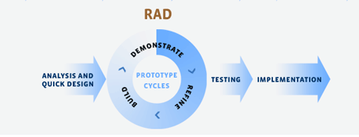

**3.3 THE JAMES MARTIN RAD MODEL:**

The phases of RAD model are listed below:

1. **Planning**: In this phase, the tasks and activities are planned. The derivables produced from this phase are project definition, project management procedures, and a work plan. Project definition determines and describes the project to be developed. Project management procedure describes processes for managing issues, scope, risk, communication, quality, and so on. Work plan describes the activities required for completing the project.
2. **Analysis:** The requirements are gathered at a high level instead of at the preciseset of detailed requirements level. In case the user changes the requirements, RAD allows changing these requirements over a period of time. This phase determines plans for testing, training and implementation processes. Generally, the RAD projects are small in size, due to which high level strategy documents are avoided.
3. **Prototyping:** The requirements defined in the analysis phase are used todevelop a prototype of the application. A final system is then developed with the help of the prototype. For this, it is essential to make decisions regarding technology and the tools required to develop the final system.
4. **Repeat analysis and prototyping as necessary**: When the prototype isdeveloped, it is sent to the user for evaluating its functioning. After the modifiedrequirements are available, the prototype is updated according to the new set of requirements and is again sent to the user for analysis.
5. **Conclusion of prototyping**: As a prototype is an iterative process, the project manager and user agree on a fixed number of processes. Ideally, three iterations are considered. After the third iteration, additional tasks for developing the software are performed and then tested. Last of all, the tested software is implemented.
6. **Implementation**: The developed software, which is fully functioning, is deployed at the user's end.

**3.4 DATA FLOW DIAGRAMS:**

Data flow diagram (DFD) represents the flows of data between different processes in a business. It is a graphical technique that depicts information flow and the transforms that are applied as data move form input to output. It provides a simple, intuitive method for describing business processes without focusing on the details of computer systems. DFDs are attractive technique because they provide what users do rather than what computers do.

* 1. **REGISTRATION**

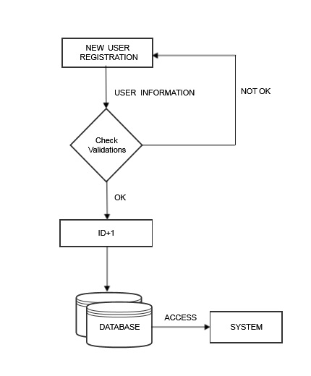

**Fig.3.4.1**

**2. LOGIN**

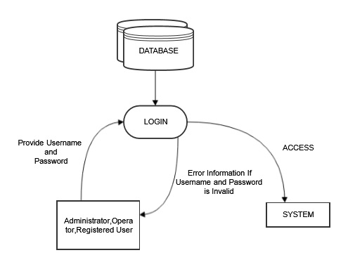

**Fig.3.4.2**

**3. FORGOT PASSWORD:**

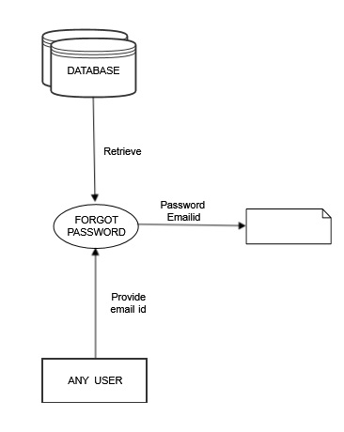

**Fig.3.4.3**

**4. CHANGE PASSWORD:**

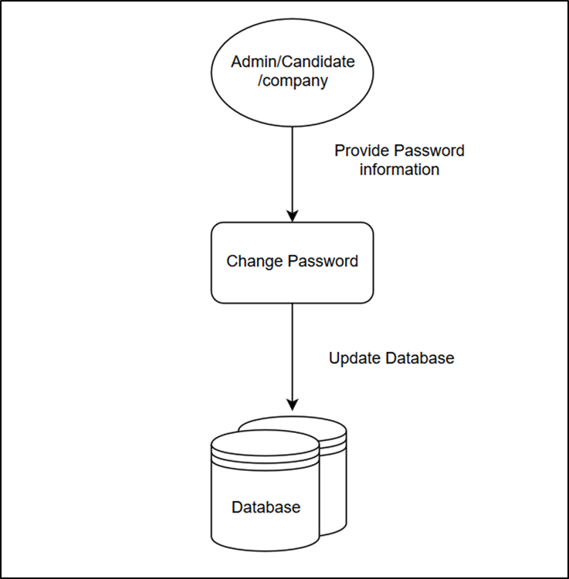

**Fig.3.4.4**

**5. MANAGE PROFILE:**

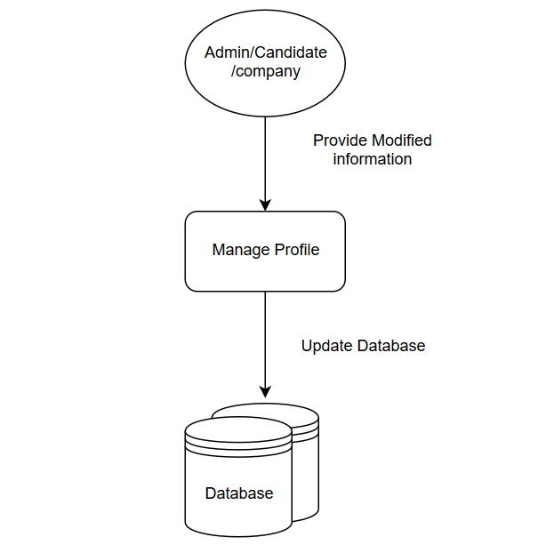

**Fig.3.4.5**

**6. ADMINISTRATER:**

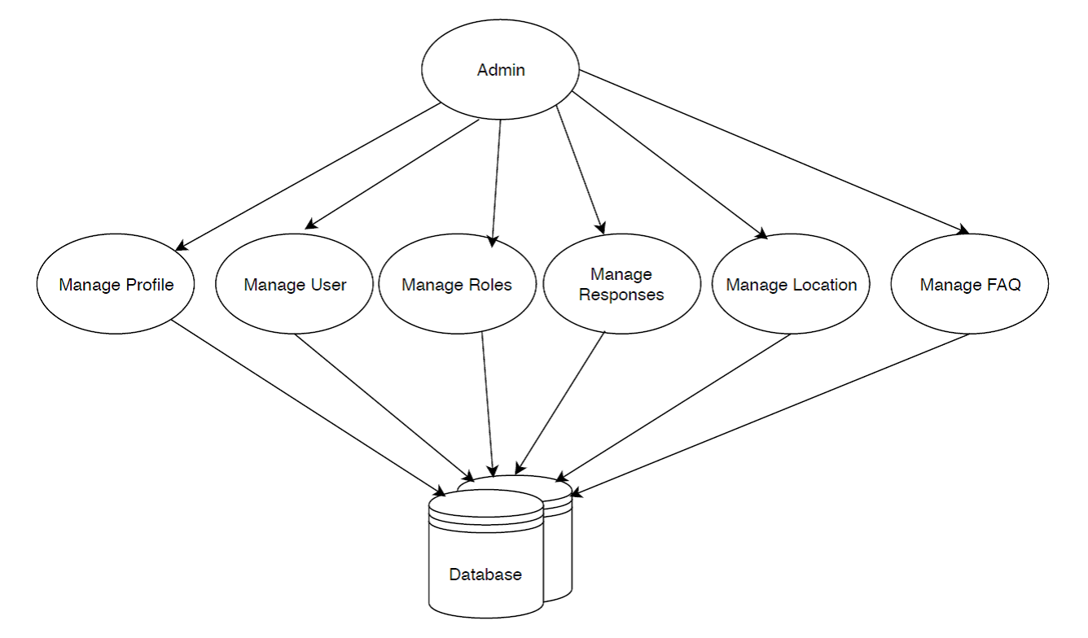

**Fig.3.4.6**

**7. COMPANY:**

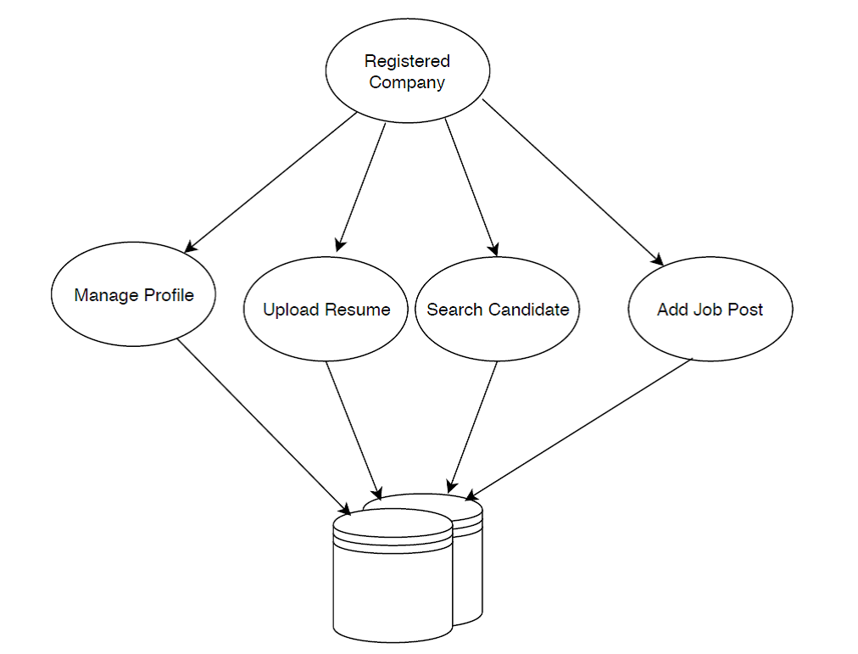

**Fig.3.4.7**

**8. REGISTERED USER:**

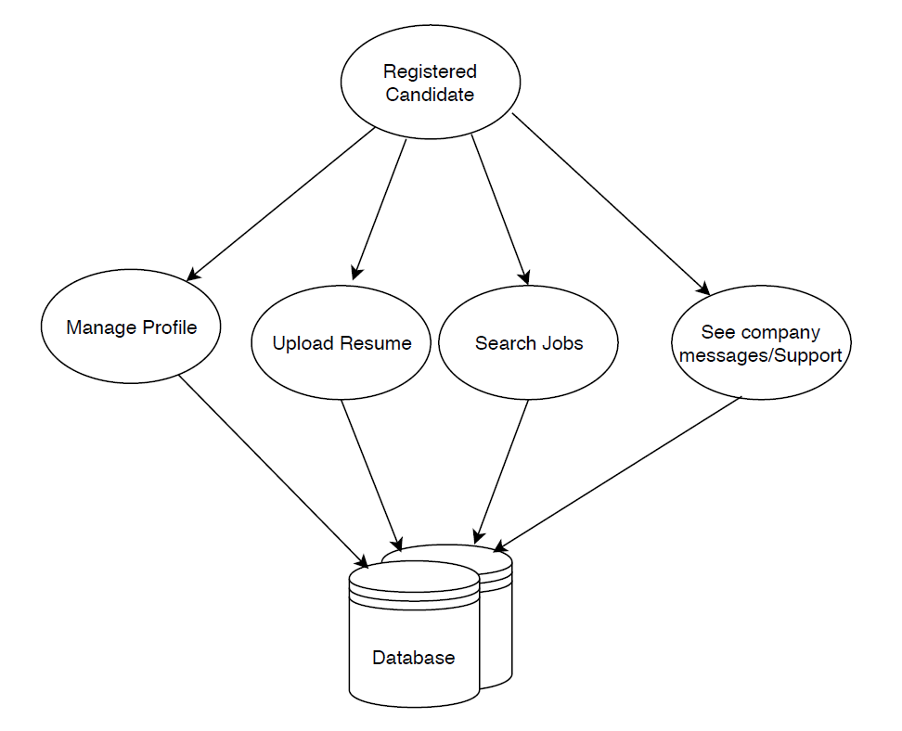

**Fig.3.4.8**

**9. UNREGISTERED USER:**

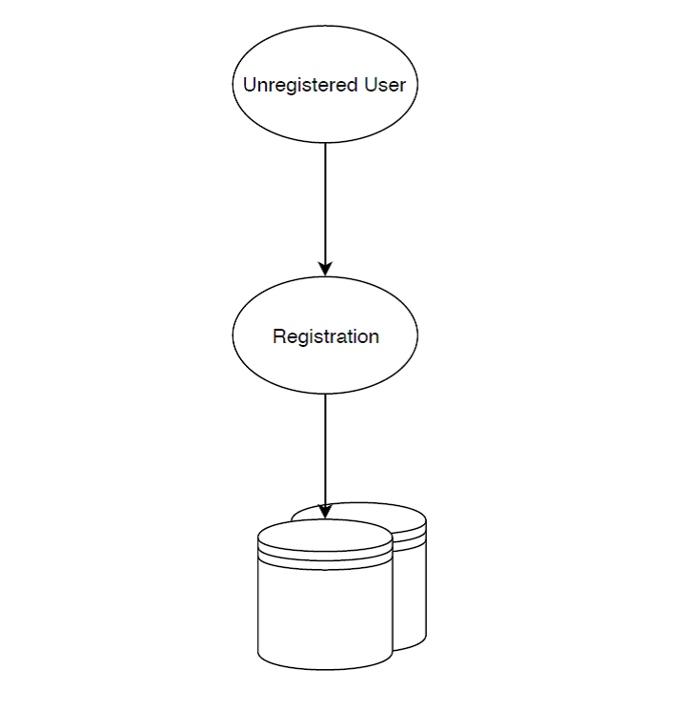

**Fig.3.4.9**

**3.5 DATA MODEL:**

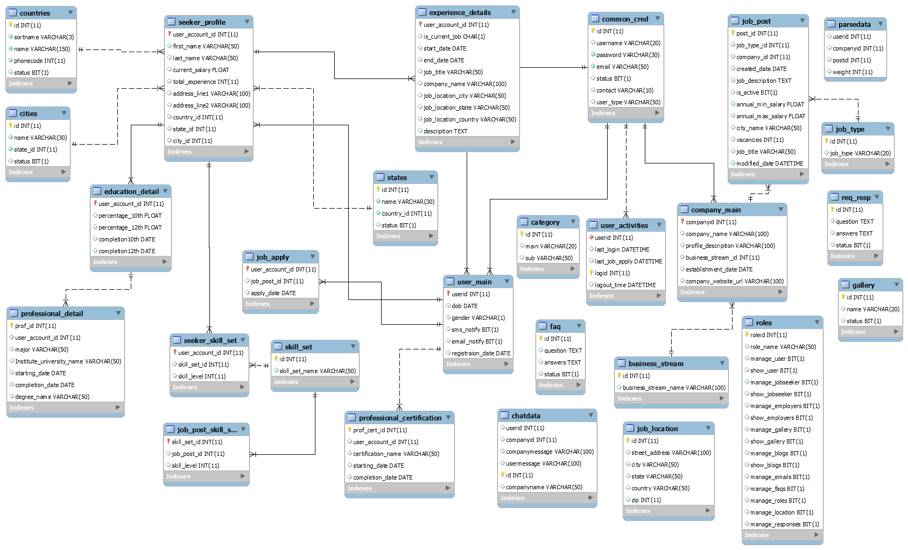

**Fig.3.5.1**

**3.6 TABLES:**

**SHOW TABLES:**

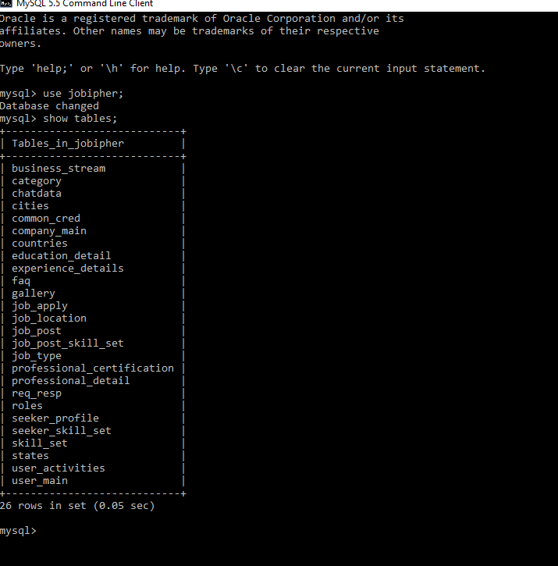

**Tables.1**

**3.7 MODULES:**

Various modules of the Jobipher would be:

* **Administration:**

Manage Users

Manage Roles

Manage Countries

Manage States

Manage City

Manage FAQs

Manage Profile

Change Password

* **Operator:**

Manage User

Manage Profile

Change Password

* **Employer:**

Company Dashboard

Manage Profile

Manage Jobs

Search Candidates

Add Jobs

Upload Resume

Change Password

* **User:**

User Dashboard

Education Details

Manage Job seeker

Manage Experience

Search Jobs

View Preferred Jobs

Upload Resume

See Messages

Change Password

**3.8 BUSINESS FUNCTIONS:**

* **CompanyUserChatServices:**
* Addusermessage
* Showcompanymessage
* **FAQService:**
* getFAQ
* changeStatus
* getStatus
* **JobPostServices:**
* getAllJobs
* getResumes
* changeJobStatus
* **LoginServices:**
* authenticateUser
* forgetpassword
* **Mainalgorithmservices:**
* getMain
* getSub
* **ManageCityServices:**
* getAllCities
* **ManageCompanyService:**
* getStreams
* updatePassword
* addJD
* addCompany
* getCity
* getnames
* **ManageCountryServices:**
* getAllCountries
* **ManageGalleryServices:**
* getGallery
* deleteUser
* addGallery
* getName
* updateGallery
* getGalliry
* changeStatus
* getStatus
* getNames
* **ManageJobSeekerService:**
* getSkills
* getSkill
* addJobSeeker
* addSkillSet
* addExperience
* getWholeInfo
* ViewAllJobs
* **ManageRole:**
* addRole
* updateRole
* getAllRoles
* getRole
* **ManageStateServices:**
* getAllStates
* **ManageUsers:**
* Signup
* getAllUsers
* UserActivity
* addUser
* deleteUser
* editUser
* editProfile
* changeCityStatus
* changeStateStatus
* changeCountryStatus
* changeStatus
* getName
* updatePassword
* getprofile
* VerifyUsername
* **ModifyLocation:**
* addCity
* addCountry
* addState
* getCitybean
* updateCity
* getCountries
* getStates
* getCities
* **ReqRespService:**
* getReqResp
* deleteRequest
* addRequest
* updateResponse
* **seeker_details_services:**
* addDetails
* addDetails2
* addDetails3

**3.9 USERS & THEIR ROLES:**

**ADMINISTRATOR:**

Admin is responsible to manage all the users and their respective roles. With this , administrator also manages faqs/responses and data of all the countries , states & cities.

**OPERATOR:**

Operator is responsible to add/delete/manage users and job-seekers. He can manage all the users and the users added by them will be verified.

**Employer:**

Employer is responsible for maintaining company’s dashboard and its respective profile. Employer can add the job which is being required by company. By adding job, employer can get a list of candidates which are eligible for that job and the job-seekers which have applied for the job. In addition to all this, employer can add resumes of multiple persons through which employer can get a rank wise list of the persons who are best-suited for that particular job.

**Job-Seeker:**

Job-seeker can apply and search for the jobs which are posted by different companies. By uploading his/her resume, job-seeker can apply for multiple jobs. Job-seeker can also manages his/her profile.

**CHAPTER-4**

**4.1 TECHNOLOGY USED**

**1. PRESENTATION LAYER:**  the user interface (UI) which displays data to the user and accepts input from the user. In a web application this is the part which receives the HTTP request and returns the HTML response The Presentation layer requires skills such as HTML, CSS and possibly JavaScript, plus UI design.

1. **BUSINESS LOGIC LAYER:** handles data validation, business rules and task specific behavior. The Business layer requires skills in a programming language so that business rules can be processed by a computer.
2. **DATA ACCESS LOGIC LAYER**- communicates with the database by constructing SQL queries and executing them via the relevant API. The Data Access layer requires SQL skills in the form of Data Definition Language (DDL) and Data Manipulation Language (DML), plus database design

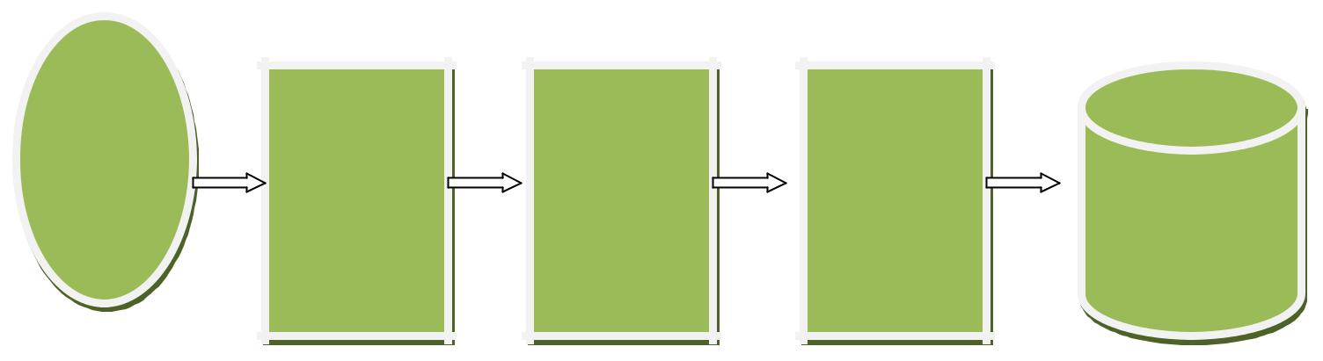

**USER PRESENTATION BUSINESS DATA ACCESS**

**LAYER LOGIC LAYER LOGIC LAYER DATABASE**

**Fig.4.1.1**

**4.2 HARDWARE REQUIREMENTS**

• **Minimum Hardware Configurations**

◦ Processor: 800MHz Intel Pentium III or equivalent

◦ Memory: 512 MB

◦ Disk space: 750 MB of free disk space

◦ Screen resolution is 1024x768 pixels.

• **Recommended Hardware Configurations**

◦ Processor: Intel Core i5 or equivalent

◦ Memory: 2 GB (32-bit), 4 GB (64-bit)

◦ Disk space: 1.5 GB of free disk space

◦ Screen resolution is 1024x768 pixels.

**4.3 SOFTWARE REQUIREMENTS**

1. **JDK 1.8**

**2. IDE**

* Net Beans 8.1

**3. Database**

* MySQL Database Server 5.5

**4. Web Server**

* Tomcat 8.0.1

**5. Application Server**

* Glassfish v4.1

**6. Testing Tool**

* JUnit 4.8.2

**7. Operating System**

* Microsoft Windows xp and above / linux /mac

**4.4 EXTERNAL LIBRARIES/API**

**1.MySQL JDBC Driver**

**2.Activation.jar**

**3.Mail.jar**

**4. Commons-fileupload-1.4.jar**

**5. Commons-io-2.4.jar**

**6. Pdfbox-app-2.0.4.jar**

**7. Ejml-0.23-src.zip**

**8. Common-io-2.2.jar**

**9.JDK 1.8**

**10. Ejml-0.23-src.jar**

**11. Javax.activation-api-1.2.0-source.jar**

**12. Javax.activation-api-1.2.0.jar**

**13. Javax.jason-api-1.0-sources.jar**

**14. Javax.jason.jar**

**15. Jaxp-api-2.4.0-b180830.0359-source.jar**

**16. Jaxp-api-2.4.0-b180830.0359.jar**

**17. Jaxb-core-2.3.0.1-sources.jar**

**18. Jaxb-core-2.3.0.1.jar**

**19. Jaxb-impl-2.4.0-b180830.0438-sources.jar**

**20. Jaxb-impl-2.4.0-b180830.0438.jar**

**21. Joda-time-2.9-sources.jar**

**22. Joda-time.jar**

**23. Jollyday-0.4.9-sources.jar**

**24. Jollyday.jar**

**25. Protobuf.jar**

**26. Slf4j-api.jar**

**27. Slf4j-simple.jar**

**28. Stanford-corenlp-3.9.2-javadoc.jar**

**29. Stanford-corenlp-3.9.2-models.jar**

**30. Stanford-corenlp-3.9.2-sources.jar**

**31. Stanford-corenlp-3.9.2.jar**

**32. Xom-1.2.10-src.jar**

**33. Xom.jar**

**34. Glassfish server 4.1.1**

**CHAPTER-5**

**5.1ALGORITHM**

**1. TOKENIZATION**

Tokenization is the process of breaking a stream of text into words, phrases, symbols, or other meaningful elements called tokens .The aim of the tokenization is the exploration of the words in a sentence. The list of tokens becomes input for further processing such as parsing or text mining.

NON-WORD REMOVAL

From every document in our dataset non-words are removed such as symbols like '@','#','&','"'.'?' etc.

**2. STOPWORD REMOVAL**

Many words in documents recur very frequently but are essentially meaningless as they are used to join words together in a sentence. It is commonly understood that stop words do not contribute to the context or content of textual documents. Due to their high frequency of occurrence, their presence in text mining presents an obstacle in understanding the content of the documents. Stop words are very frequently used common words like ‘and’, ‘are’, ‘this’ etc. They are not useful in classification of documents. So they must be removed. However, the development of such stop words list is difficult and inconsistent between textual sources. This process also reduces the text data and improves the system performance. Every text document deals with these words which are not necessary for text mining applications.

Stop-words, which are language-specific functional words, are frequent words that carry no information (i.e., pronouns, prepositions, conjunctions). In English language, there are about 400-500 Stop words. Examples of such words include 'the', 'of’, ‘and', 'to'.

**3. SYNONYM REMOVAL**

Synonyms are removed from each document using Word Net library. For e.g. if a text contains "hello","hi","howdy","hullo","how-to-do" then "hi","howdy","hullo" all are replaced by "hello".

**4. STEMMING**

Stemming techniques are used to find out the root/stem of aword. Stemming converts words to their stems, which incorporates a great deal of language=dependent linguistic knowledge. Behind stemming, the hypothesis is that words with the same stem or word root mostly describe same or relatively close concepts in text and so words can be conflated by using stems. For example, the words, user, users, used, using all can be stemmed to the word 'USE'. In the present work, the Porter Stemmer algorithm, which is the most commonly used algorithm in English, is used.

**5.2 RESUME PARSING ALGORITHM**



**6. TFIDF CALCULATION**

**TERM-WEIGHTING**

In the vector space model, the documents are represented as vectors. Term weighting is an important concept which determines the success or failure of the classification system. Since different terms have different level of importance in a text, the term weight is associated with every term as an important indicator .The TWO components that affect the importance of a term in a document are the Term Frequency (TF) factor, Inverse Document Frequency (IDF) factor. Term frequency of each word in documents (TF) is a weight which depends on the distribution of each word in resume. It expresses the importance of the word in the resume. Inverse document frequency of each word in the document database (IDF) is a weight which depends on the distribution of each word in the job description database. It expresses the importance of each word in the job description database. TF/IDF is a technique which uses both TF and IDF to determine the weight a term.

**Term frequency:**

Suppose we have a set of resume and wish to determine which resume is most relevant to the job description. A simple way to start out is by eliminating resume that do not contain relevant skill set mentioned in job description, but this still leaves many resumes. To further distinguish them, we might count the number of times each skill set from job description occurs in each resume, sum them all together and multiply then with IDF which is calculated from the job description; the number generated but the sum of all the relevant terms in a resume is called its term frequency (TF).

In the case of the term frequency tf(t,d), the simplest choice is to use the raw frequency of a term in a document, i.e. the number of times that term t occurs in document d. If we denote the raw frequency of t by ft,d, then the simple tf scheme is tf(t,d) = ft,d.

**Inverse document frequency:**

Because the term "java" is so common, term frequency will tend to incorrectly emphasize documents which happen to use the word "java" more frequently, without giving enough weight to the more meaningful terms "J2SE" and "J2EE". The term "java" is not a good keyword to distinguish relevant and non-relevant resume and terms, unlike the less common words "J2SE" and "J2EE". Hence an inverse document frequency factor is incorporated which diminishes the weight of terms that occur very frequently in the document set and increases the weight of terms that occur rarely.

**CHAPTER-6**

**6.1 TESTING**

JUnit is a unit testing framework for the Java programming language. JUnit has been important in the development of test-driven development, and is one of a family of unit testing frameworks collectively known as xUnit that originated with JUnit.

Testing is the process of checking the functionality of the application whether it is working as per requirements and to ensure that at developer level, unit testing comes into picture. Unit testing is the testing of single entity (class or method). Unit testing is very essential to every software company to give a quality product to their customers.

Unit testing can be done in two ways:

|  |  |
| --- | --- |
| **MANUAL TESTING** | **AUTOMATED TESTING** |
| Executing the test cases manually without any tool support is known as manual testing.   * Time consuming and tedious: Since test cases are executed by human resources so it is very slow and tedious. * Huge investment in human resources: As test cases need to be executed manually so more testers are required in manual testing. * Less reliable: Manual testing is less reliable as tests may not be performed with precision each time because of human errors. * Non-programmable: No programming can be done to write sophisticated tests which fetch hidden information. | Taking tool support and executing the test cases by using automation tool is known as automation testing.   * Fast Automation runs test cases significantly faster than human resources. * Less investment in human resources:Test cases are executed by using automation tool so less tester are required in automation testing. * More reliable: Automation tests perform precisely same operation each time they are run. * Programmable: Testers can program sophisticated tests to bring out hidden information. |

**WHAT IS JUNIT?**

JUnit is a unit testing framework for the Java Programming Language. It is important in the test driven development, and is one of a family of unit testing frameworks collectively known as xUnit.

JUnit promotes the idea of "first testing then coding", which emphasis on setting up the test data for a piece of code which can be tested first and then can be implemented . This approach is like "test a little, code a little, test a little, code a little..." which increases programmer productivity and stability of program code that reduces programmer stress and the time spent on debugging.

**FEATURES**

* JUnit is an open source framework which is used for writing & running tests.
* Provides Annotation to identify the test methods.
* Provides Assertions for testing expected results.
* Provides Test runners for running tests.
* JUnit tests allow you to write code faster which increasing quality
* JUnit is elegantly simple. It is less complex & takes less time.
* JUnit tests can be run automatically and they check their own results and provide immediate feedback. There's no need to manually comb through a report of test results.
* JUnit tests can be organized into test suites containing test cases and even other test suites.
* Junit shows test progress in a bar that is green if test is going fine and it turns red when a test fails.

**WHAT IS JUNIT TEST CASE?**

A Unit Test Case is a part of code which ensures that the another part of code (method) works as expected. To achieve those desired results quickly, test framework is required .JUnit is perfect unit test framework for java programming language.

A formal written unit test case is characterized by a known input and by an expected output, which is worked out before the test is executed. The known input should test a precondition and the expected output should test a post condition.

There must be at least two unit test cases for each requirement: one positive test and one negative test. If a requirement has sub-requirements, each sub-requirement must have at least two test cases as positive and negative.

**CHAPTER-7**

**CONCLUSIONS & FUTURE SCOPE**

Resume parsers are already standard in most mid- to large-sized companies and this trend will continue as the parsers become even more affordable.

A qualified candidate's resume can be ignored if it is not formatted the proper way or doesn't contain specific keywords or phrases. As Machine Learning and Natural Language Processing get better, so will the accuracy of resume parsers.

One of the areas resume parsing software is working on expanding into is performing contextual analysis on the information in the resume rather than purely extracting it. One employee at a parsing company said “a parser needs to classify data, enrich it with knowledge from other sources, normalize data so it can be used for analysis and allow for better searching.”

Parsing companies are also being asked to expand beyond just resumes or even LinkedIn profiles. They are working on extracting information from industry-specific sites such as **GitHub** and social media profiles.

With recent advancements in AI sophistication and Machine Learning, and the text mining and analysis processes improvements, which ensure up to 95% accuracy in the data processing, many AI technologies have sprung up to help the job seekers in the creation of application documents. These services focus on creating ATS-friendly resumes, execute resume check and screening, and help with all of the preparation and application processes. Some of the AI builders, such as Leap.ai and Skillroads, concentrate on the resume creation while others, like Stella, also offer help with the job hunt itself as they match candidates to appropriate vacancies. In 2017, Google made an attempt at dismantling the US$215.68 Bn (as of 2017) global recruitment market via the creation of Google for Jobs, which is predicted to greatly affect the labor market. This expansion to the search engine uses Cloud Talent Solution, Google's own invention, which is another iteration of the smart AI resume builder and matching system.

**CHAPTER-8**

**SCREEN SHOT**

**Home Page:**

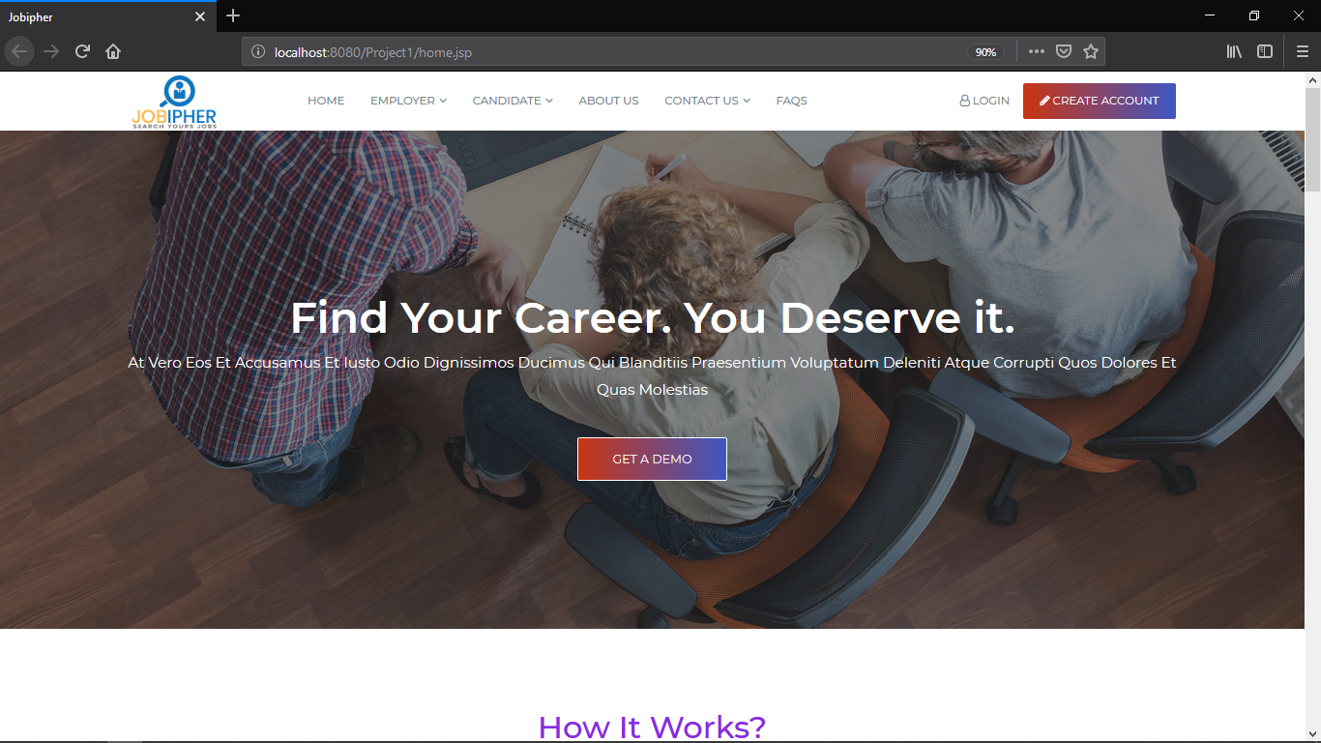

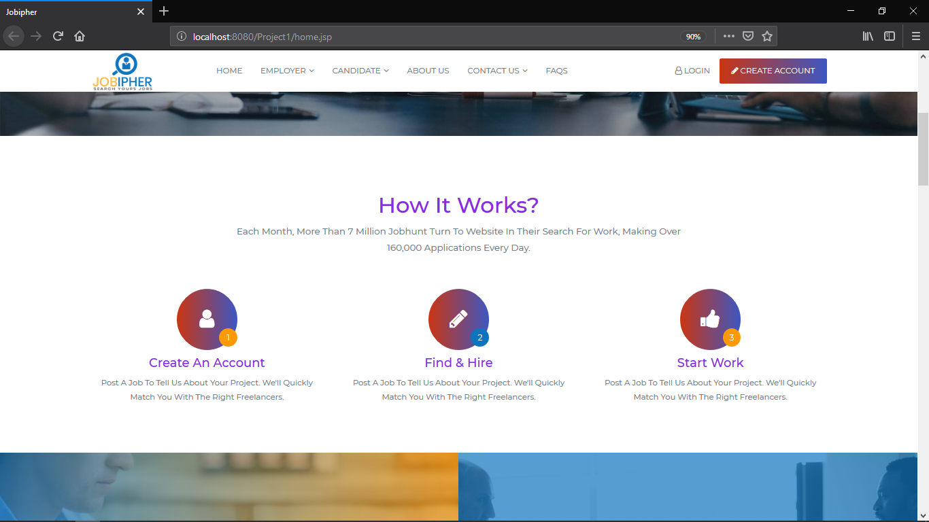

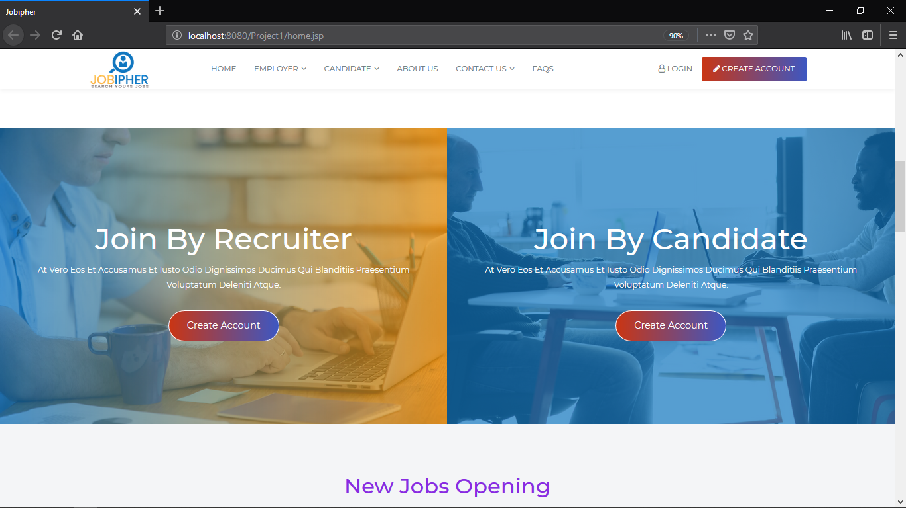

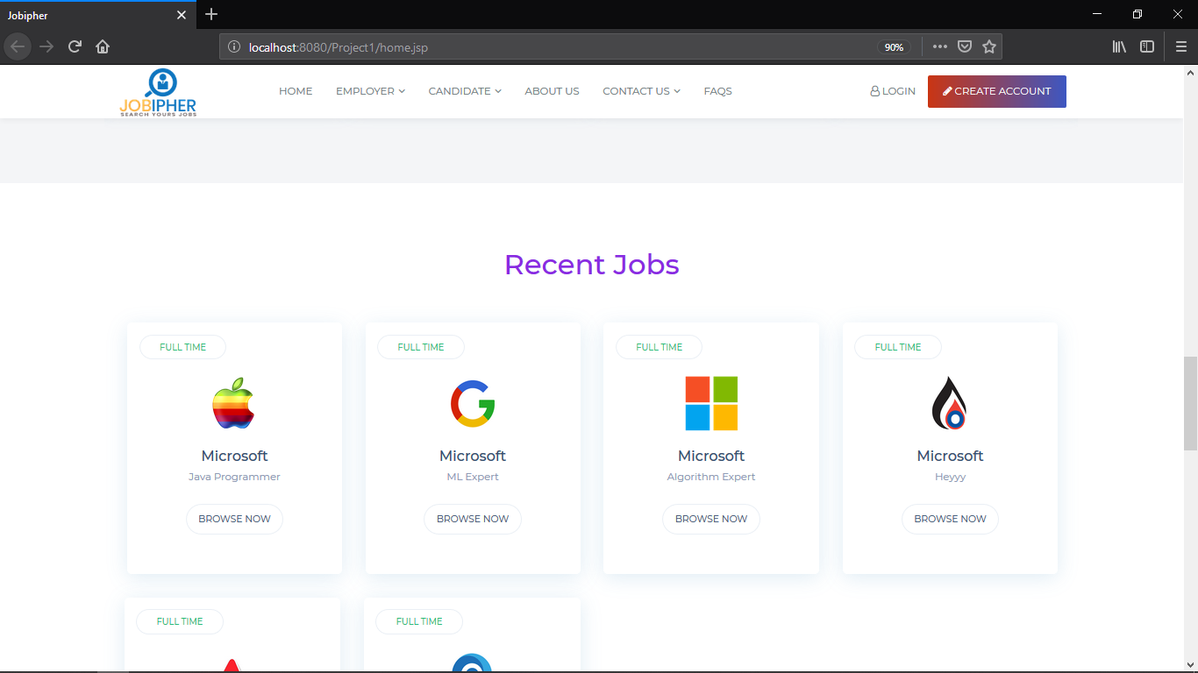

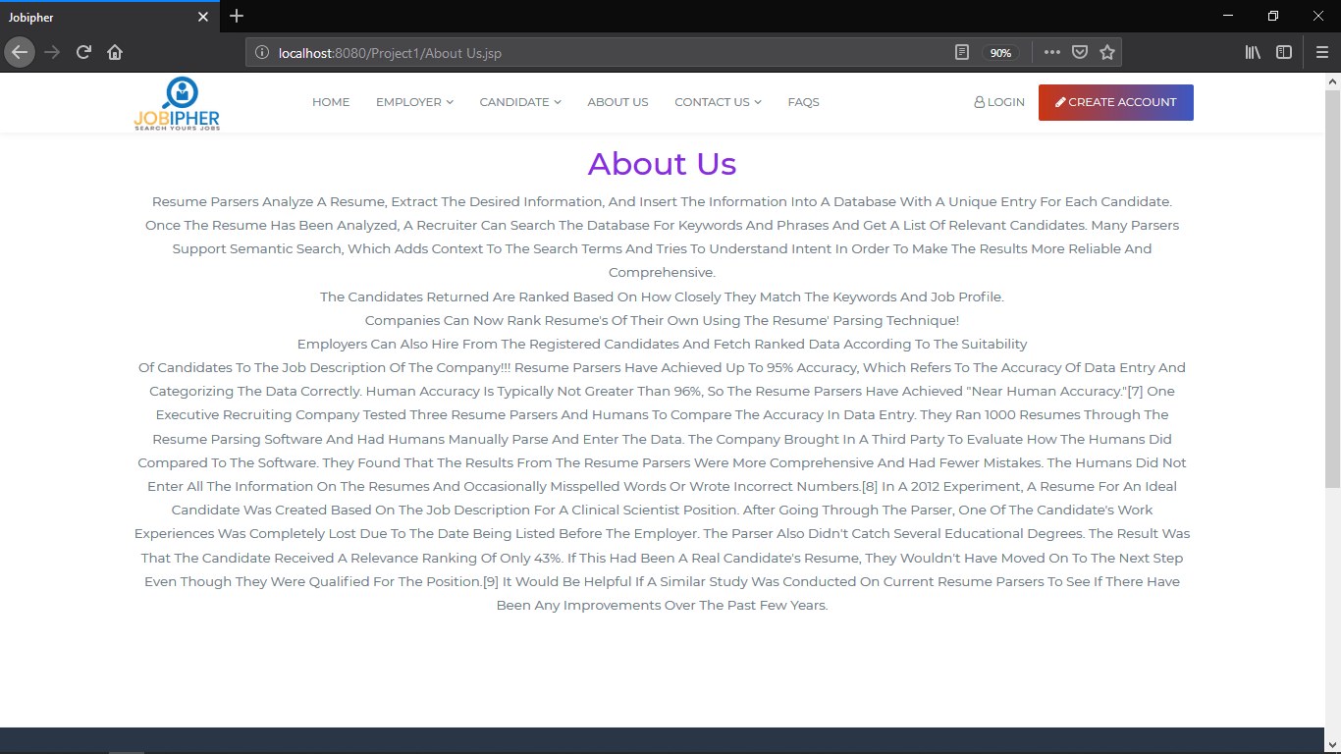

**Sign Up Portal:**

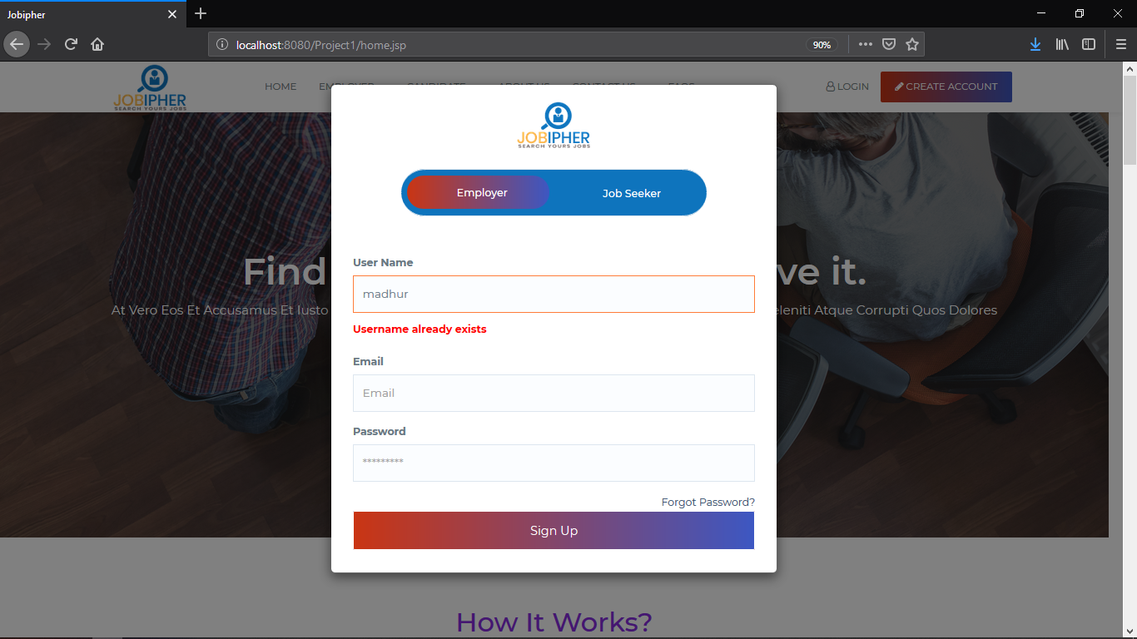

**Login Portal:**

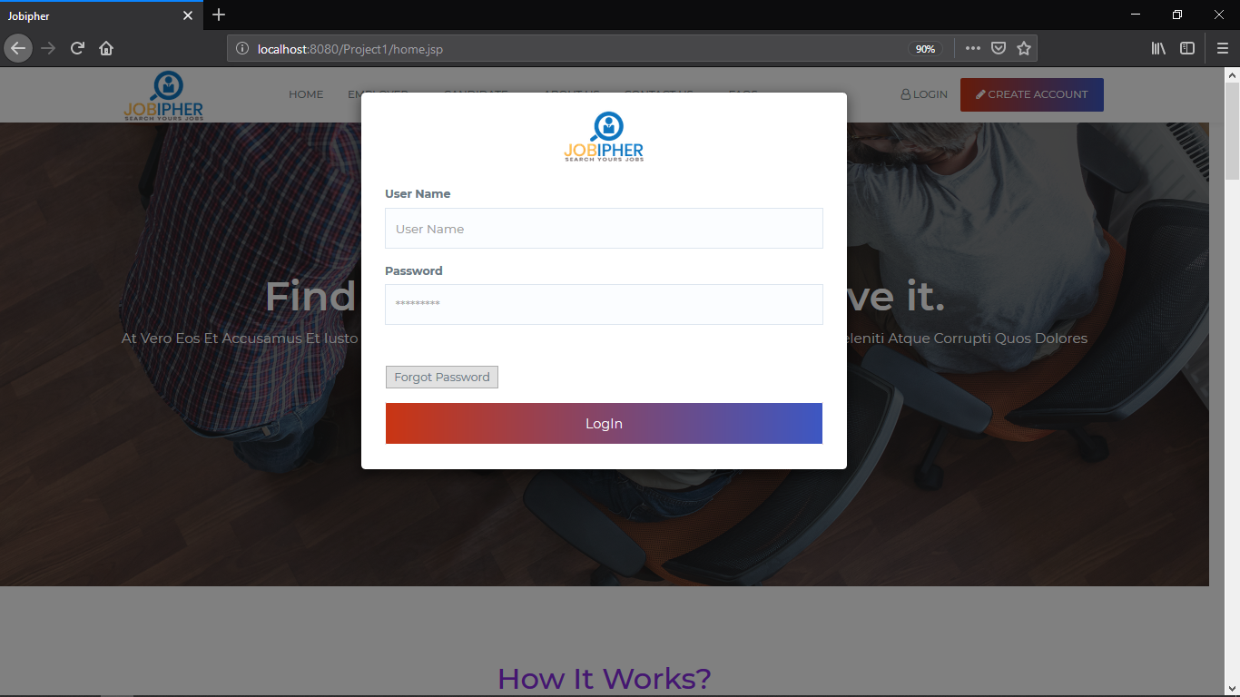

**Company Portal:**

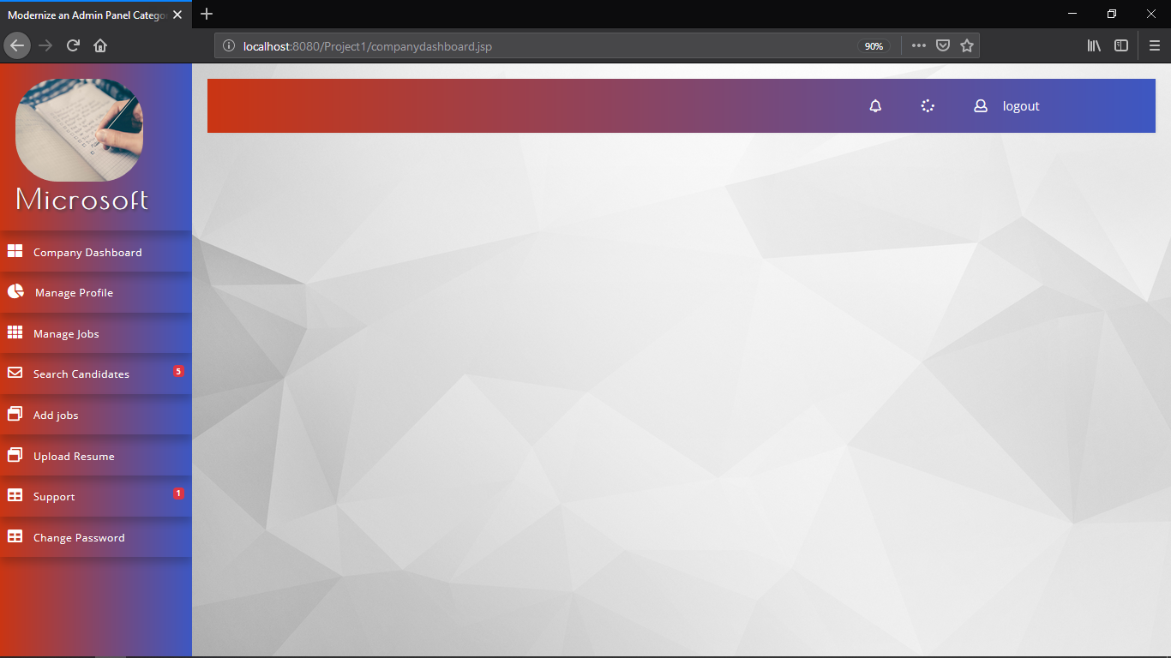

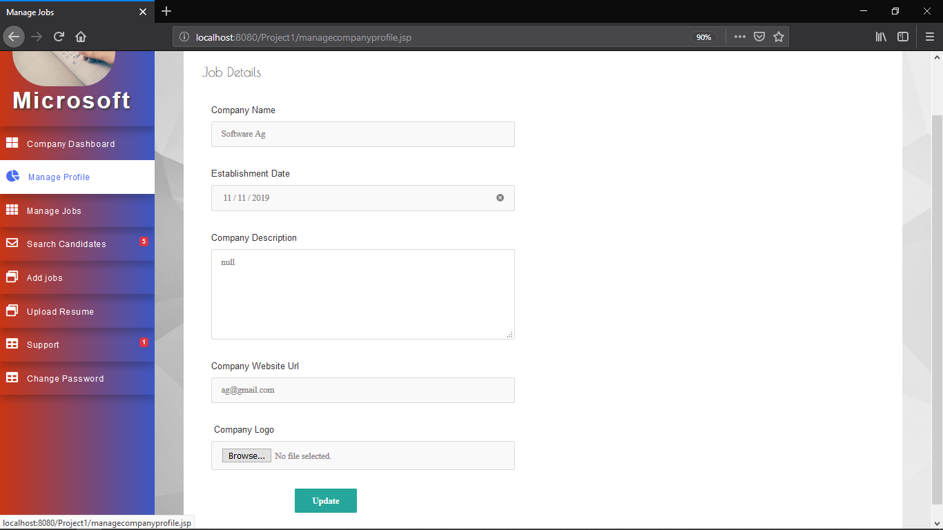

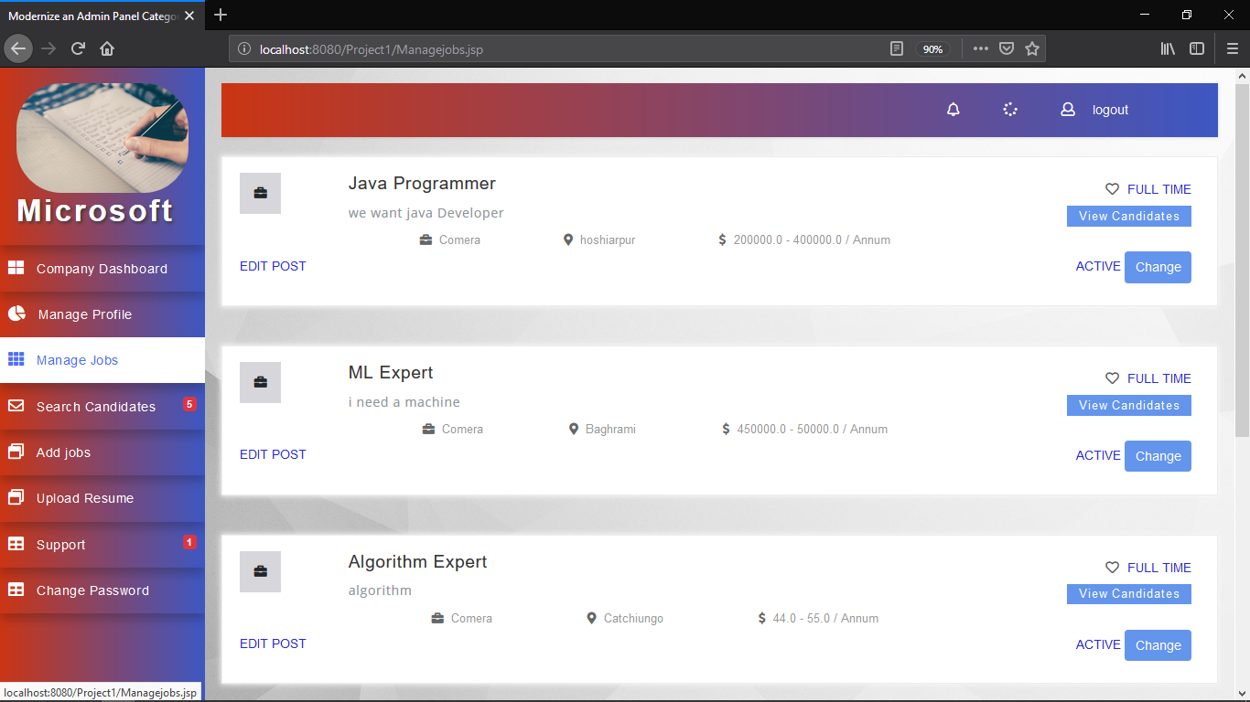

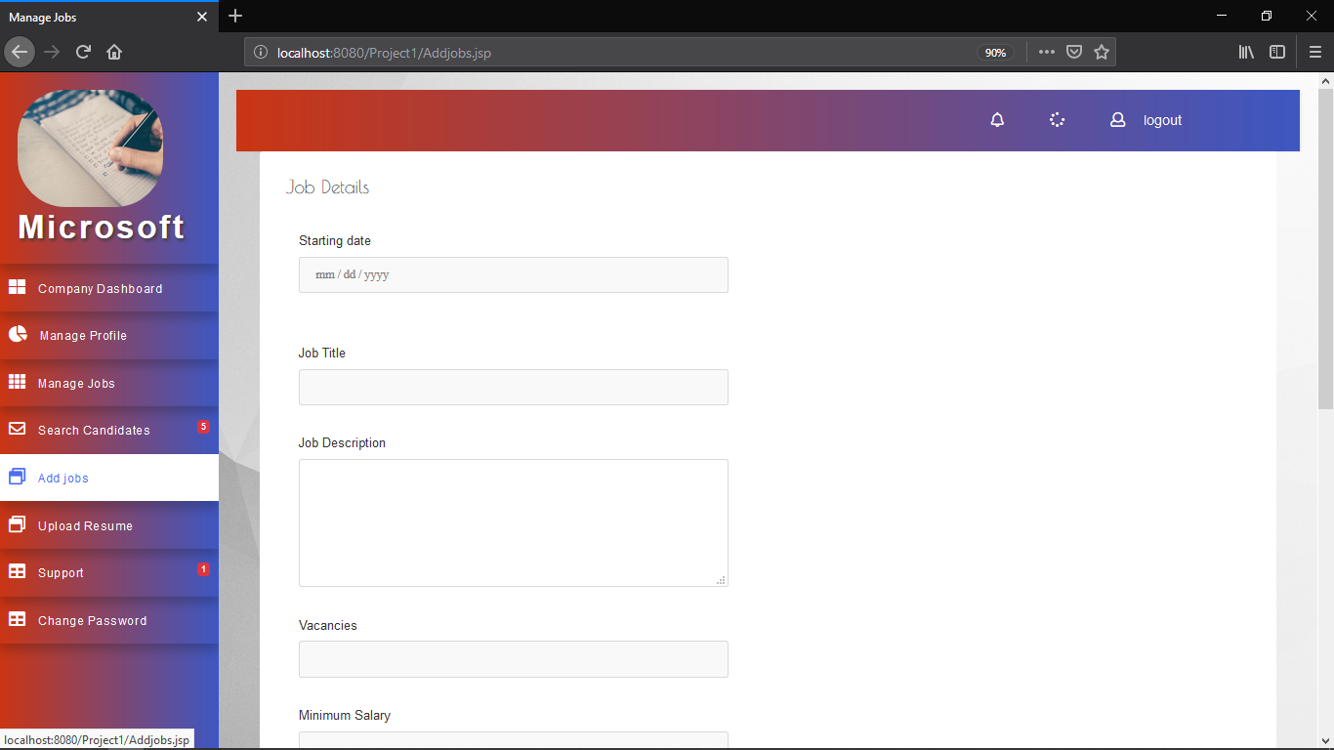

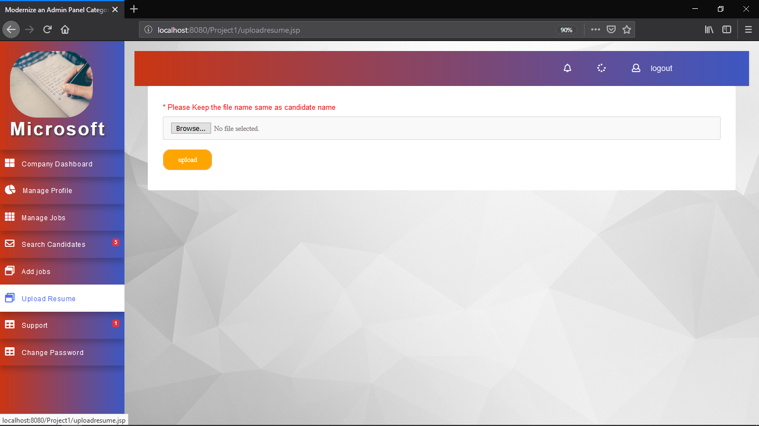

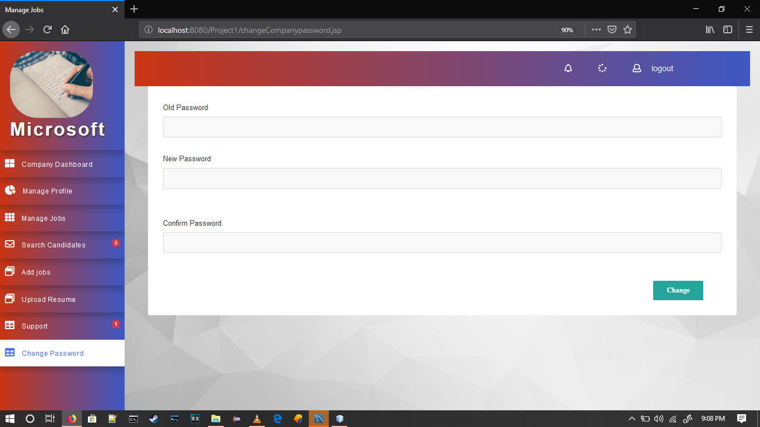

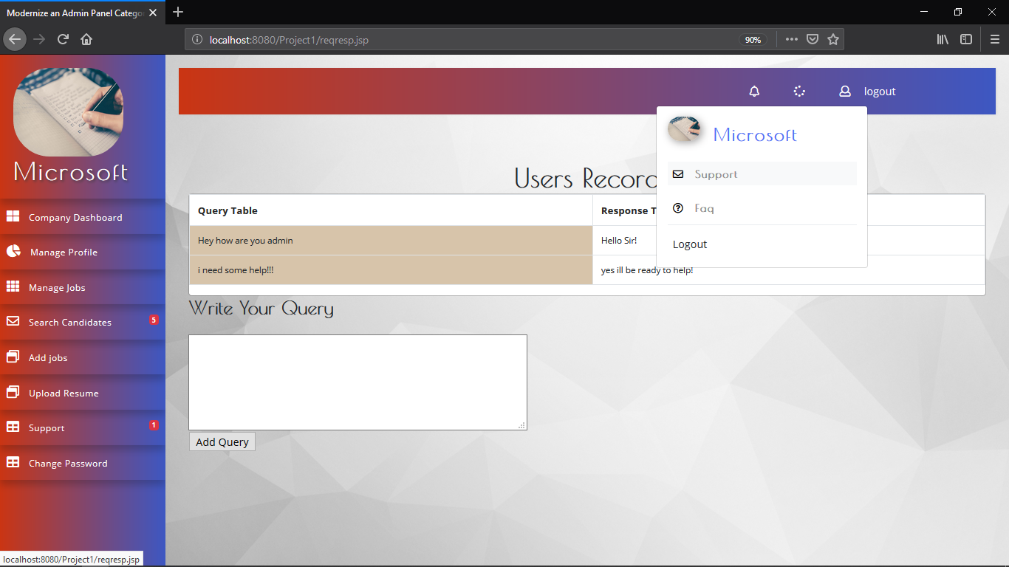

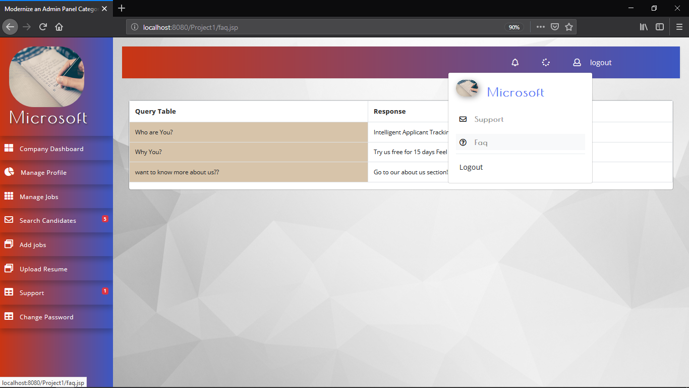

**Job-Seeker Portal:**

